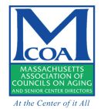
Mass in Motion Fall River
Healthy Aging Walk Audit Report
July 23th @ 10:00 AM

Audit Route:
West on Pleasant Street (From Flint Senior Center) to Flint Street, then to Quequechan Street, to Alden Street, to Flint Street, then East back onto Pleasant Street.
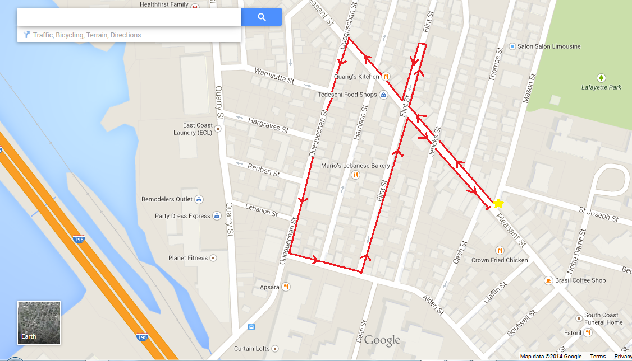
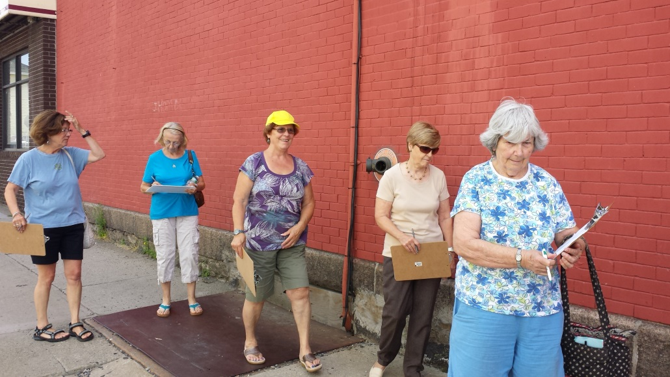
Champions in attendance:
Annette Audette
Kathy Duclos
Richard & Laura Lopes
Julie Cleare
Kathy Lowney

MIM/PHC representatives in attendance:
Marcia Picard
Eric Andrade
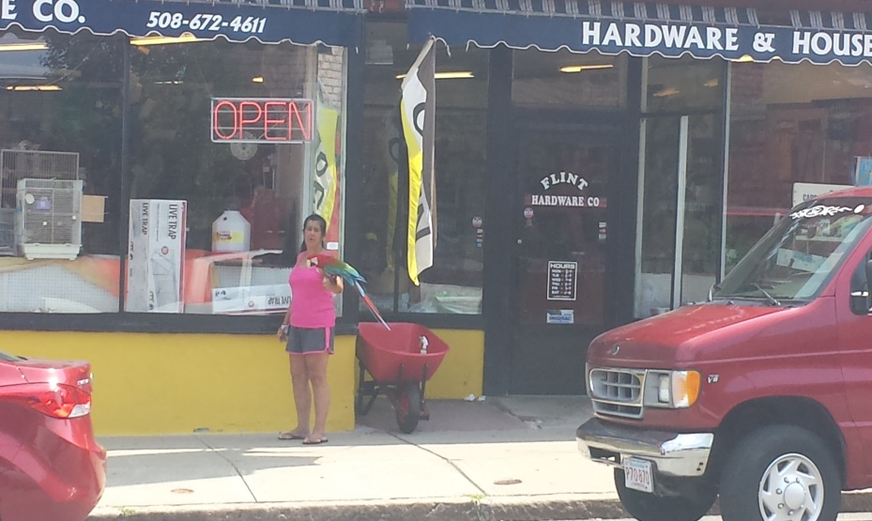
The second of the Flint walk audits began out of the Flint Senior Center at 1423 Pleasant Street. Eight total auditors were present, six of which were enlisted champions. The representative from Mass in Motion Fall River was Eric Andrade and Marcia Picard, School Wellness Coordinator through Partners for a Healthier Community was also present.
Like the first audit along Pleasant Street, this area is a heavy mix of residential and commercial units. Small local businesses line Pleasant Street on both sides, usually accompanied with tenement apartment units above each establishment. This brings a large amount of foot traffic across Pleasant Street, as well as the streets running off of it. Whereas the first audit took place between Cash Street and Eastern Avenue, this particular audit focused on the section of Pleasant Street between Quequechan Street and Cash Street.
The auditors walked westward on Pleasant Street, noting that the sidewalks were in fair shape. They were wide, and in good condition. The crosswalks running across Pleasant Street and along the adjacent side streets were seen to be in poor shape. These crosswalks were initially barely visible. Thankfully, this lower section of Pleasant Street received freshly painted crosswalks a few weeks after the audit took place, with piano key style crosswalks being put in across Pleasant.
The audit took a brief detour off of Pleasant Street onto Flint Street to view the Davol School, which within the next few years will become the Flint Neighborhood Association Community Center. This community center will bring in high volumes of pedestrian traffic to the neighborhood, as many businesses and groups will be moving their operations into the center. Some of these include the Pleasant Street post office branch, the library branch currently on Pleasant Street, the Sons of Portugal, Twilight Baseball League, and many other community groups. Because of this increased traffic, it is especially important that the sidewalks and streets be in the best condition possible. Many residents of the Flint walk to their destinations, and the community center will certainly be a top destination in the near future.
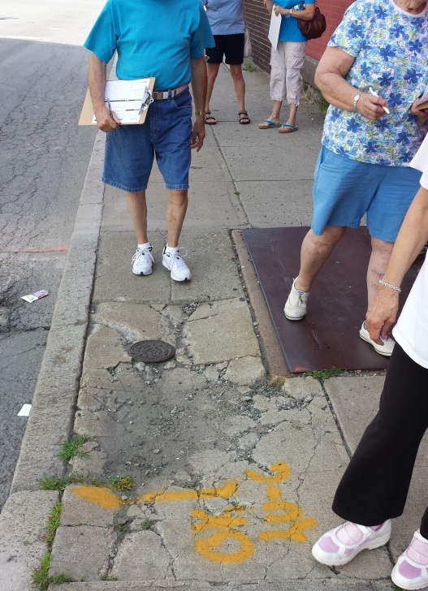
After turning back onto Pleasant, the group made its way to the intersection of Pleasant and Quequechan Street. Quequechan Street runs North to South, and links Pleasant Street, Quarry Street, and Jefferson Street, which are all heavily used roads. The group immediately noticed the difference between the sidewalk conditions on Quequechan in comparison to Pleasant. The sidewalks are in bad shape, as was the street. Much of the street looks similar to the photo on the right. Sidewalks slabs are frequently cracked and utility mains are exposed. This presents a real hazard for tripping, especially for Seniors and those with disabilities.
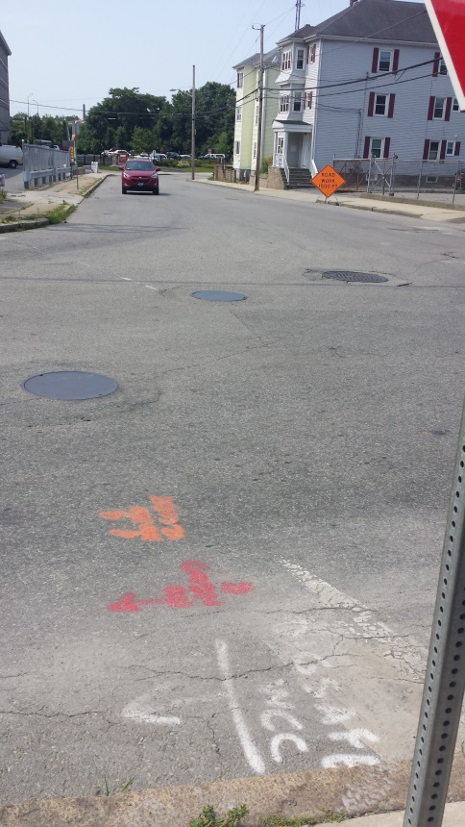
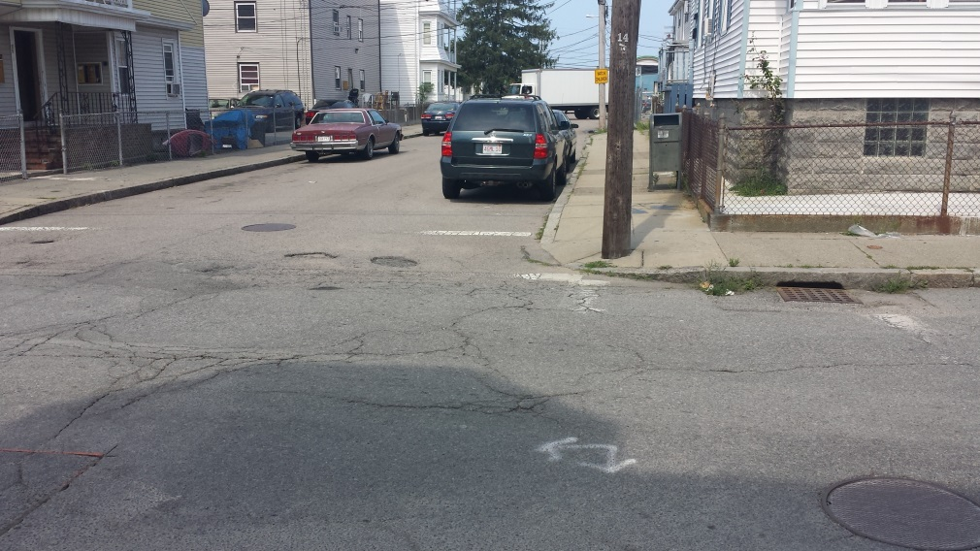
Another major problem with Quequechan Street was the condition of the crosswalks. Many of the crosswalks were so barely visible that it seemed as if there was no crosswalk at all. Some auditors noted that there was not one crosswalk along Quequechan that they felt was in proper condition. This, coupled with a lack of crosswalks actually running across Quequechan (as opposed to its side streets) makes pedestrian travelling even more risky. Cars frequently travel down the street at speeds much higher than the speed limit of 30mph. As shown in the photo above, cars going at these speeds would have a tough time seeing the crosswalks, as visible paint barely even reaches the center of the street.
Quequechan is an important thoroughfare because it has become a quick access road, for both pedestrians and vehicles, to get to the new Walmart a few blocks away on Jefferson Street. With crosswalk and sidewalk conditions the way they are, there are serious risks to pedestrians. The group reached the intersection of Quequechan and Alden Street (pictured above) and saw that the intersection (which also has cars feeding in from Jefferson and Quarry) looked as if it had no crosswalks at all. Pedestrians crossing this area must use extreme caution, because vehicles can approach from many different angles. The crosswalks are in such poor shape no one traveling at a decent pace would be able to spot them.
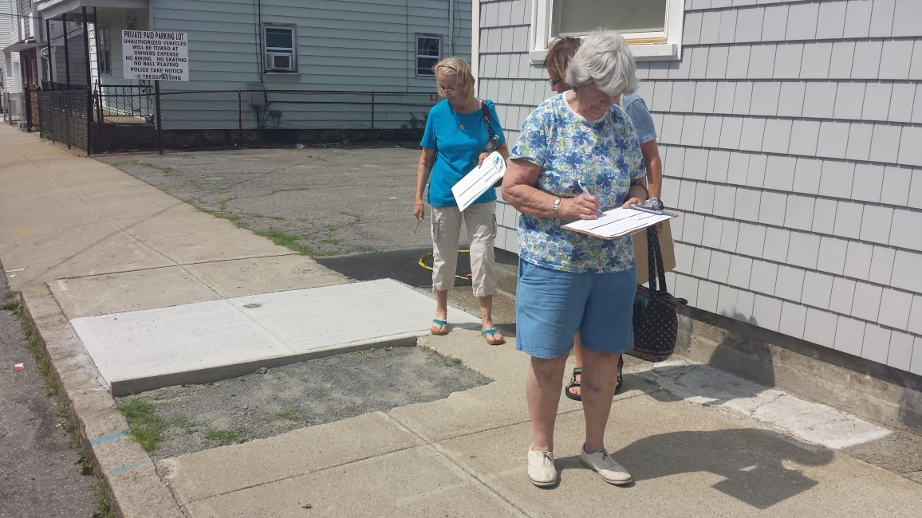
Heading East on Alden Street briefly, the group came back to Flint Street, and headed North back to Pleasant. On the way back to Pleasant, some auditors stopped into Sam’s Bakery, a famous in Fall River for its meat pies. Sam’s is certainly a top destination within the Flint, as people from all over come to the bakery during lunch breaks. The problem with this is that there is not enough parking to cover the vehicle demand. Cars park on top of sidewalks, and pull in and out of the lot without even looking. The group had to move cautiously across, because it was apparent that drivers were aggravated by having to wait.
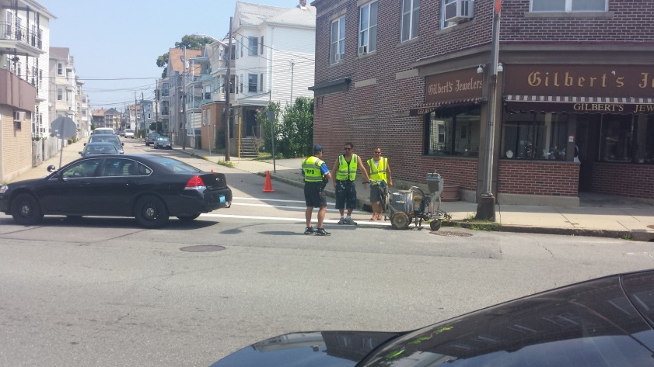
Also on Flint Street was a section of the sidewalk that was cut out, creating a sizeable drop from the normal pavement, and one of the auditors almost tripped over it. Utility cuts that are not properly sectioned off are a huge pedestrian hazard. Some auditors felt that the section was big enough that someone with a disability would have to avoid that part of the sidewalk all together.
Once the group made its way back to Pleasant Street, it was immediately noticed that the Department of Community Maintenance was going down Pleasant repainting the crosswalks. This particular stretch of painting went from Eastern Avenue to Flint Street. All of the side streets were repainted, and piano keys were put onto Pleasant, as mentioned earlier. It was a fitting end to an audit, and the auditors were glad to see progress being made.
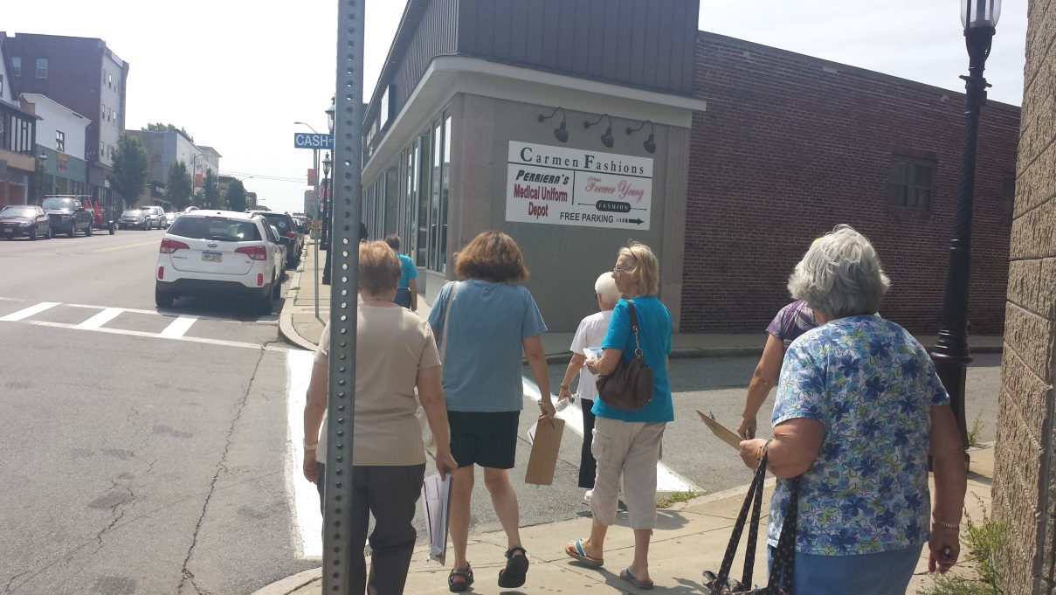

Key Points
- Sidewalk conditions on Quequechan Street are a major tripping hazard.
- Utility cuts and patchwork (On Quequechan and Flint Street) are not properly marked, and can go unseen by the pedestrian.
- Lack of crosswalks on Quequechan Street makes it difficult to cross the street with vehicle traffic constantly flowing.
- Crosswalks are needed at the intersection of Alden Street and Quequechan Street with proper curb cuts for wheelchair access.
- Overgrowth on Alden Street is filled with trash and debris, adding to the hazard.

Recommendations
- Proper signage indicating that utility cuts have been made in a sidewalk can increase pedestrian awareness and decrease potential tripping hazards.
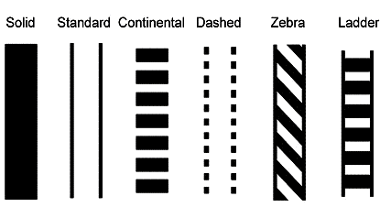
- Adding vibrant, piano-key / zebra stripe crosswalks along Quequechan and Alden Streets will slow down speeding traffic and give pedestrians a safe way to cross streets and intersections.

- Crosswalk particularly needed near the newly renovated Quequechan Street/Cathy Assad Tot-Lot at the corner of Quequechan and Wamsutta Streets. This park is consistently used by children and families in the neighborhood, who currently have no safe way to cross streets to get to the Tot-Lot.
- Clearing away overgrowth and trash on Alden Street will add to the aesthetic of the street, while allowing more room on the sidewalks for pedestrians and wheelchairs.

