MHAC Action Committee – Access, Equity and Cultural Inclusion (AECI)

Proposed Tool for Municipalities:

The MHAC Action Group on AECI proposed creating a tool for municipalities engaging in the Age- and Dementia Friendly Communities movement to be cognizant of access and equity issues so that action plans can be as inclusive as possible.

The following statements under the Eight Domains of an Age-Friendly Community are a potential guide for consideration.

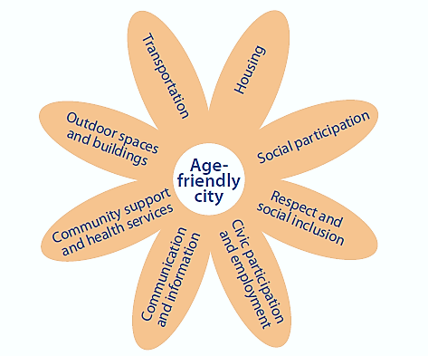
Physical Environment

Community and Health Services

Inclusion and Engagement

Transportation:

- Race
- Ethnicity
- Religion
- Income Level
- Ability Level
- Geographic Diversity (entire community is considered)
- Immigration Status
- Residential Setting (home, assisted living, public housing, SNF, etc)

Housing:

- Race
- Ethnicity
- Religion
- Income Level
- Ability Level
- Geographic Diversity (entire community is considered)
- Immigration Status
- Residential Setting (home, assisted living, public housing, SNF, etc)

Social Participation:

- Race
- Ethnicity
- Religion
- Income Level
- Ability Level
- Geographic Diversity (entire community is considered)
- Immigration Status
- Residential Setting (home, assisted living, public housing, SNF, etc)

Respect and Social Inclusion:

- Race
- Ethnicity
- Religion
- Income Level
- Ability Level
- Geographic Diversity (entire community is considered)
- Immigration Status
- Residential Setting (home, assisted living, public housing, SNF, etc)

Civic Participation and Employment:

- Race
- Ethnicity
- Religion
- Income Level
- Ability Level
- Geographic Diversity (entire community is considered)
- Immigration Status
- Residential Setting (home, assisted living, public housing, SNF, etc)

Communication and Information:

- Race
- Ethnicity
- Religion
- Income Level
- Ability Level
- Geographic Diversity (entire community is considered)
- Immigration Status
- Residential Setting (home, assisted living, public housing, SNF, etc)

Community Support and Health Services:

- Race
- Ethnicity
- Religion
- Income Level
- Ability Level
- Geographic Diversity (entire community is considered)
- Immigration Status
- Residential Setting (home, assisted living, public housing, SNF, etc)

Outdoor Buildings and Spaces:

- Race
- Ethnicity
- Religion
- Income Level
- Ability Level
- Geographic Diversity (entire community is considered)
- Immigration Status
- Residential Setting (home, assisted living, public housing, SNF, etc)

