MHAC Action Committee – Policy and Advocacy
Proposed Criteria for Collaborative Support

Statements Based on Eight Domains:

These statements are collectively and individually meant to serve as criteria for deciding whether to support a legislative initiative.

It should be noted that “support” has yet to be defined, but the discussion has been that MHAC would offer supportive written testimony if more than one statement is satisfied, but would promote the policy via blog and social media if it satisfied at least one of the statements.

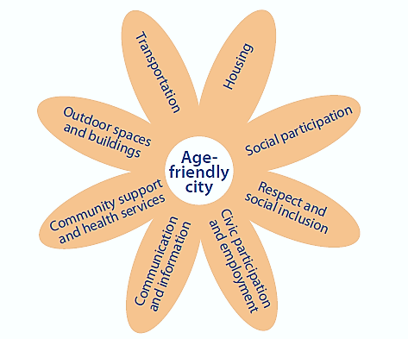
Physical Environment

Community and Health Services

Inclusion and Engagement

Transportation:
- This policy helps improve access to transportation options for older adults and people living with dementia with consideration to different ability levels.

- This policy may create or enhance training of transportation providers and workers to be more respectful of older adults and people living with dementia.

- This policy allows regional transit authorities and/or cities and towns to be more flexible in offering transportation options to older adults and people living with dementia.

Housing:
- This policy increases affordable and accessible housing options for older adults and people living with dementia, with consideration to different ability levels.

- This policy allows cities and towns to be more flexible in improving housing options to help older adults and people living with dementia to remain in their homes and/or communities.

Social Participation:
- This policy directly or indirectly combats social isolation by increasing opportunities for older adults and people living with dementia to be connected to others in their community through community social events, local arts and cultural events, councils on aging, YMCA, and in-home visiting services, among others.

Respect and Social Inclusion:
- This policy promotes an embedded view of healthy aging and living with dementia along the lines of an “aging in all policies” approach where state and local government agencies or departments view their work through an aging/disability lens.

- This policy may promote intergenerational programs and activity.

- This policy addresses inclusion regardless of race, ethnicity, sexual orientation, ability level, income level, place of residence or residential setting (i.e. assisted living, affordable housing, etc).

Civic Participation and Employment:
- This policy promotes an employer’s ability to be “age-friendly,” and enhances opportunities for older adults or remain in, or rejoin, the workforce.

- This policy allows cities and towns and/or community-based organizations to increase opportunities for tax work-off programs and volunteerism among older adults and people living with dementia.

- This policy promotes civic participation among older adults, including, but not limited to voting and conducting business with a city or town.

- This policy promotes Age/Dementia Friendly businesses

Communication and Information:
- This policy promotes linking older adults, people with dementia and their caregivers to pertinent and easy-to-understand information to improve health and well-being.

- This policy improves an older adult’s ability to use technology or receive information in a manner, language or other medium that is relevant and understandable.

Community Support and Health Services:
- This policy helps strengthen a community’s ability to provide public health and/or preventative services to its residents.

- This policy promotes access of older adults and people living with dementia to health care and/or support services

Outdoor Buildings and Spaces:
- This policy allows communities to employ smart growth strategies (i.e. ensuring that development improves the community, environment, economy and public health) to become healthier places to grow old in — and better places for people of all ages.

- This policy supports communities that make changes in outdoor buildings and spaces that encourage healthy behavior.

